Lab: ApplicationSet

**In github in argocdappset folder :**

**Modify dev and proj sub-folder yaml file (namespace and service account name), how we did it lab1**

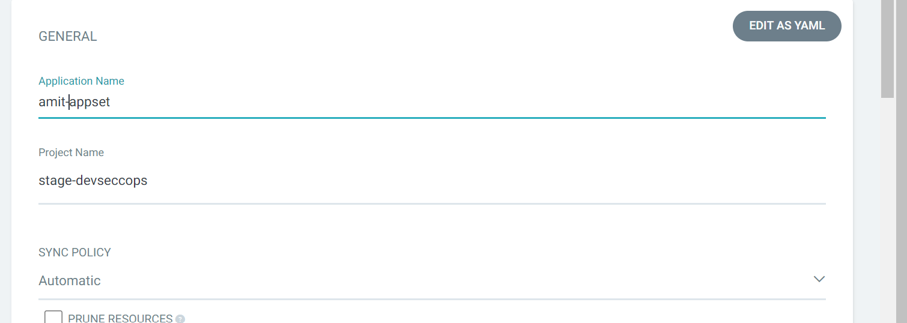

Provide the source path

Source: [git@github.com:amitopenwriteup/nginx-argoproj.git](mailto:git@github.com:amitopenwriteup/nginx-argoproj.git)

Revision: Provide the Branch name

Path: argocdappset

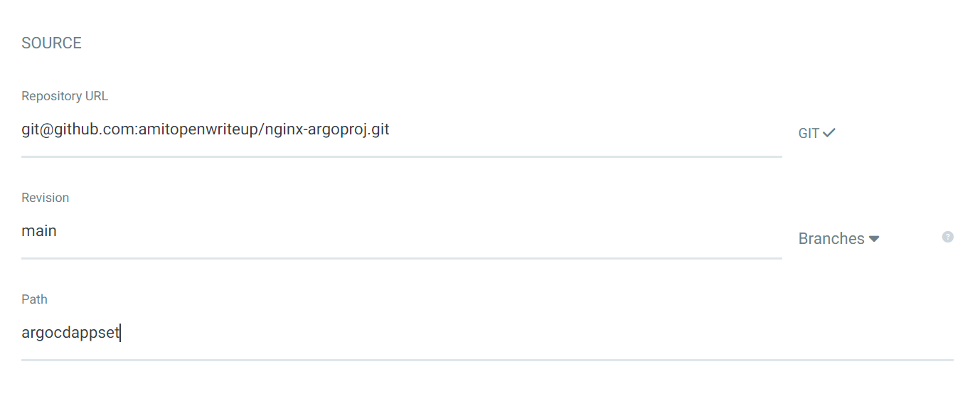

Select the name in destination

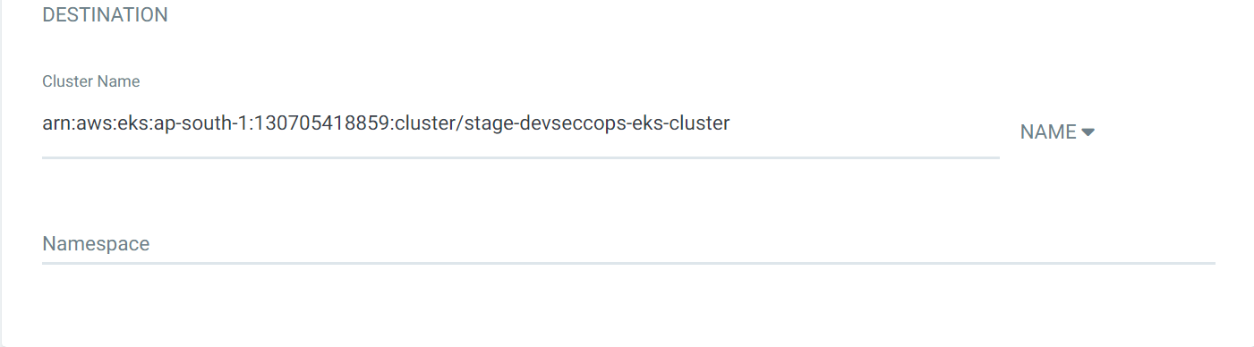

Assignment: Delete the appset